**CMPG223 GROUP PROJECT**

**GROUP 19**

Lecturers: Mr Nathan Morgenrood

Mr Heinke Lubbe

Group members: P Nel – 34263306

HTN Quinn – 42263867

B Zvomuno – 31709974

O Zungu – 42132975

A Murray – 33485356

R Lombaard – 33619190

Contents

Database schema: 3

Database and tables in sql server explorer 3

Sql used to create database 3

Tables 3

Clients tables 3

Employees table 4

Roles table 4

Project assignments table 5

Project schedules table 5

Project phases tables 5

Sql used to maintain db 6

Maintaining clients table 6

Insert clients 6

Update clients 6

Delete clients 7

Maintaining emplyee table 7

Delete employees 7

Update employees 7

Insert employees 7

Maintaining projects table 7

Delete projects 7

Update projects 8

Insert project 8

Update project schedules 8

Querying database 8

Select employees 8

Select project 9

Use of methods 9

System reports 10

# Database schema:

## Database and tables in sql server explorer

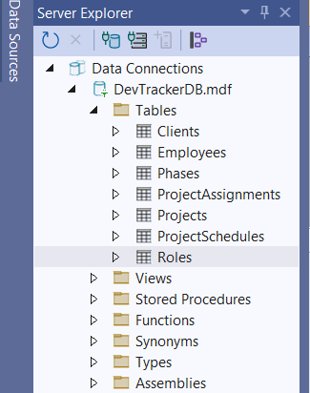

# Sql used to create database

# Tables

## Clients tables

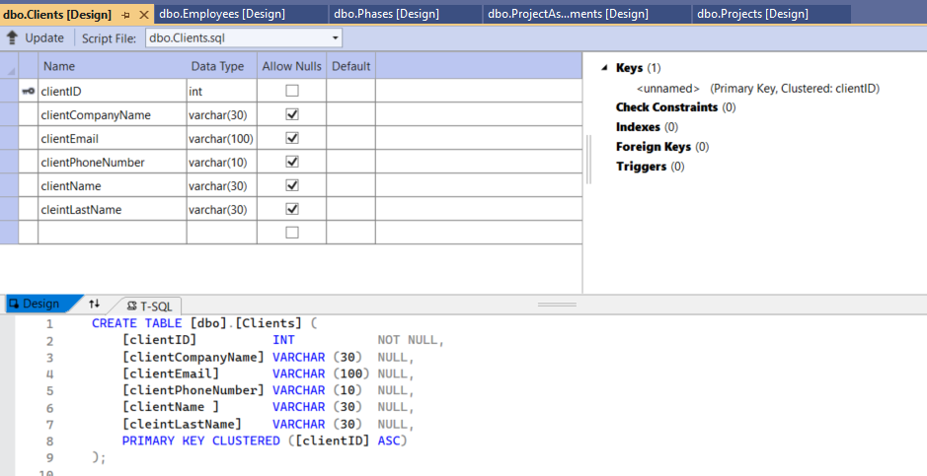

## Employees table

## Roles table

## Project assignments table

## Project schedules table

## Project phases tables

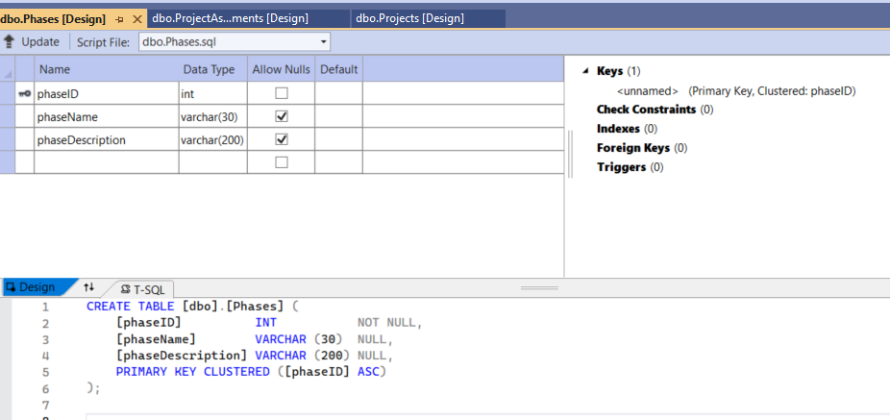

# Sql used to maintain db

## Maintaining clients table

### Insert clients

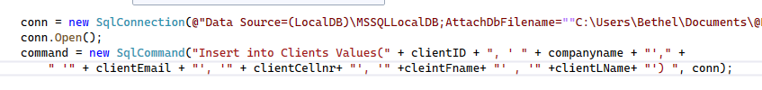

### Update clients

### Delete clients

## Maintaining emplyee table

### Delete employees

### Update employees

### Insert employees

## Maintaining projects table

### Delete projects

### Update projects

### Insert project

### Update project schedules

# Querying database

### Select employees

### Select project

# Use of methods

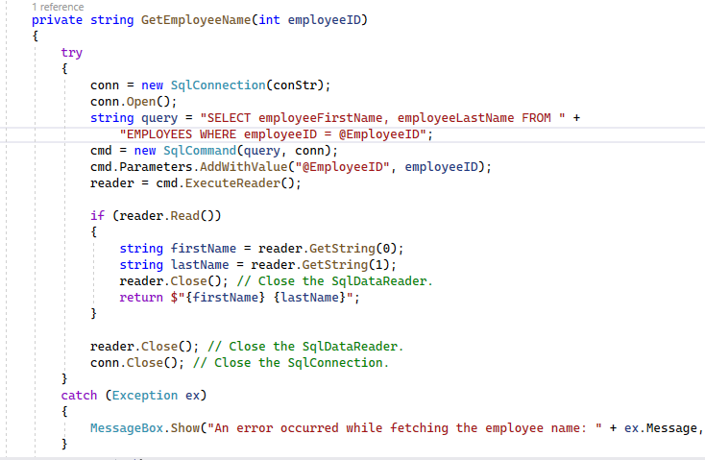

# System reports

